**Java**

**Team Member**

**1**

**2**

**2)Description & goal**

**Employee survey portal is useful for knowing getting survey detail from user & user can know their result of matching data with company data.**

**3)Detailed Description**

**Employee Survey portal is portal in which we can add employee through admin panel and we can add question for employee survey and at employee login webpage employee can give answer that question then they can know their score of matching data with company data.**

**(a) Database Schema**

**Login Validation**

|  |  |  |  |
| --- | --- | --- | --- |
| Field Name | Type | Size | Description |
| User name | Varchar2 | 50 | Store admin username |
| Password | Varchar2 | 20 | Store admin password |

**User 905**

|  |  |  |  |
| --- | --- | --- | --- |
| Field Name | Type | Size | Description |
| Id | Number | 38 | Store random id |
| Name | Varchar2 | 4000 | Store Employee Name |
| Password | Varchar2 | 4000 | Store Employee Password |
| Email | Varchar2 | 4000 | Store Employee Email |
| Country | Varchar2 | 4000 | Store Employee Country |

**Quizz**

|  |  |  |  |
| --- | --- | --- | --- |
| Field Name | Type | Size | Description |
| Question | Varchar2 | 200 | Store Quiz question |
| Answer | varchar2 | 20 | Store Quiz Answer |

**Admin**

**(1)New Admin**

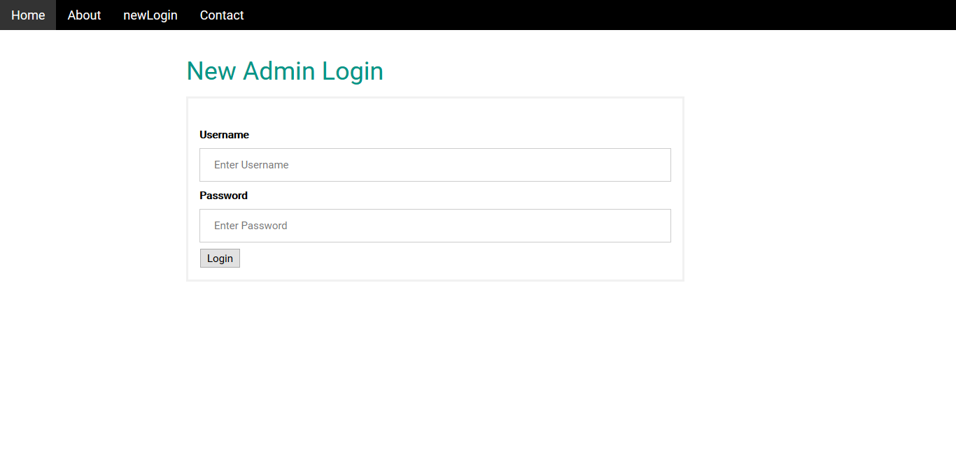

**(2)Admin Login**

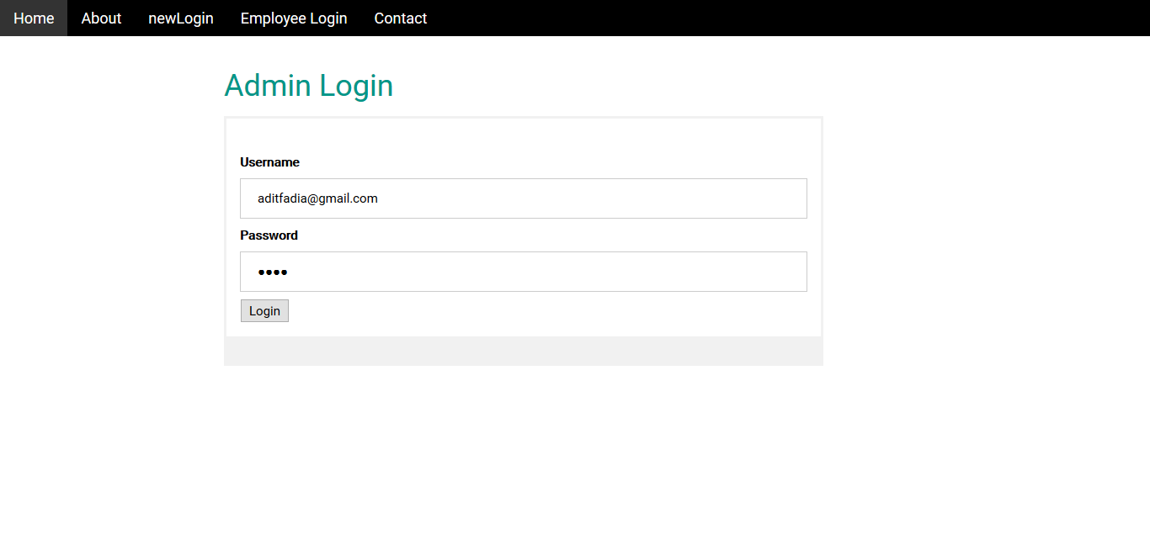

**(3)Add Employee Detail**

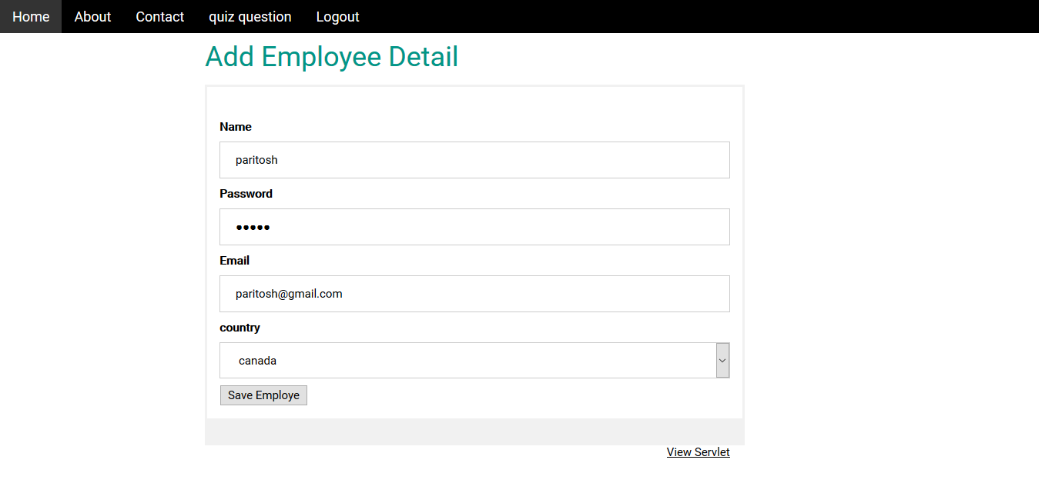

**(4) Employee Data**

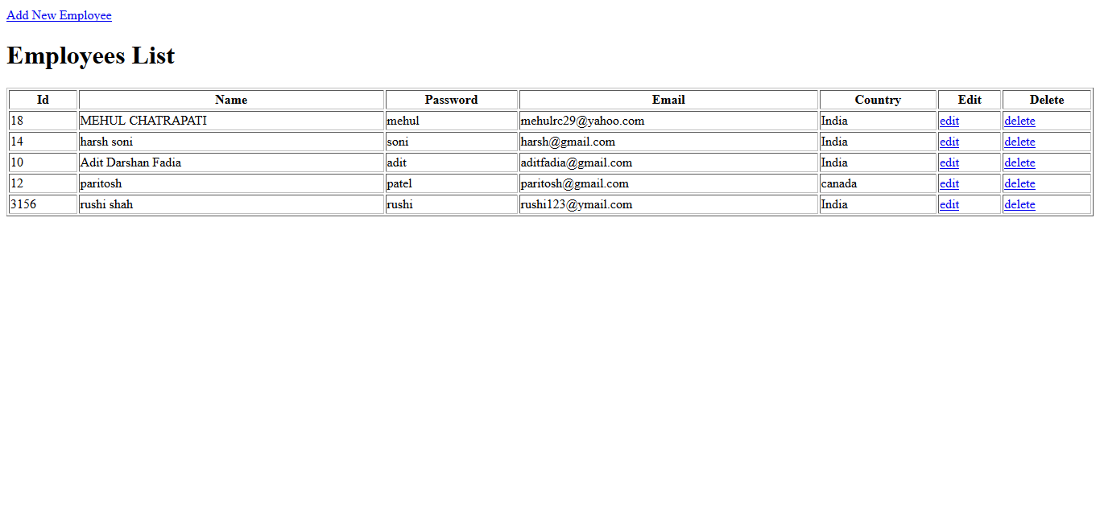

**(5)Edit Data**

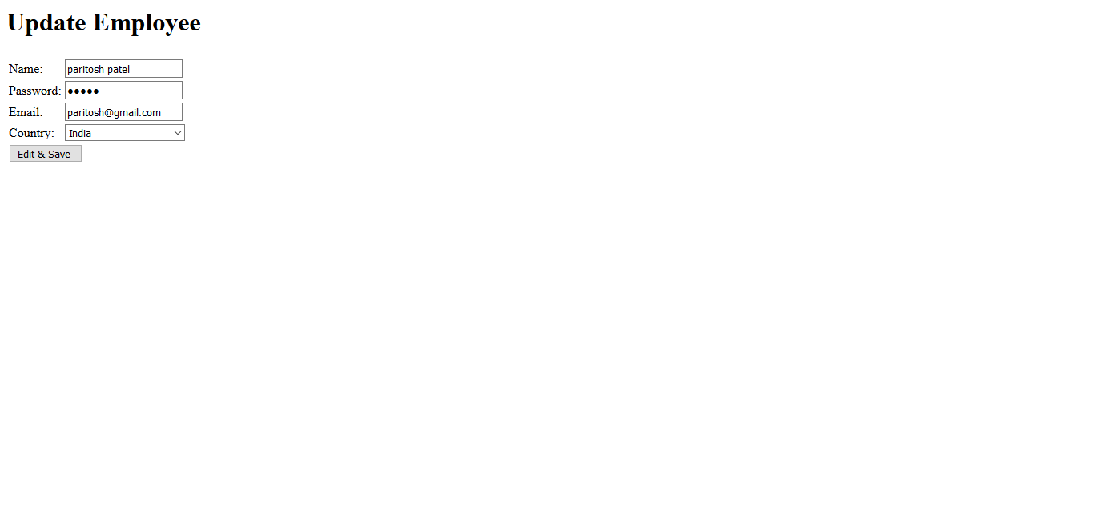

**(6) Mail**

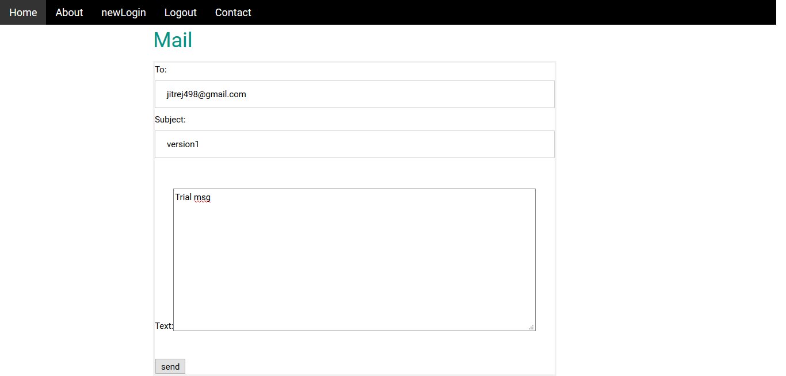

**(7) Success Message**



**(8) Quiz**

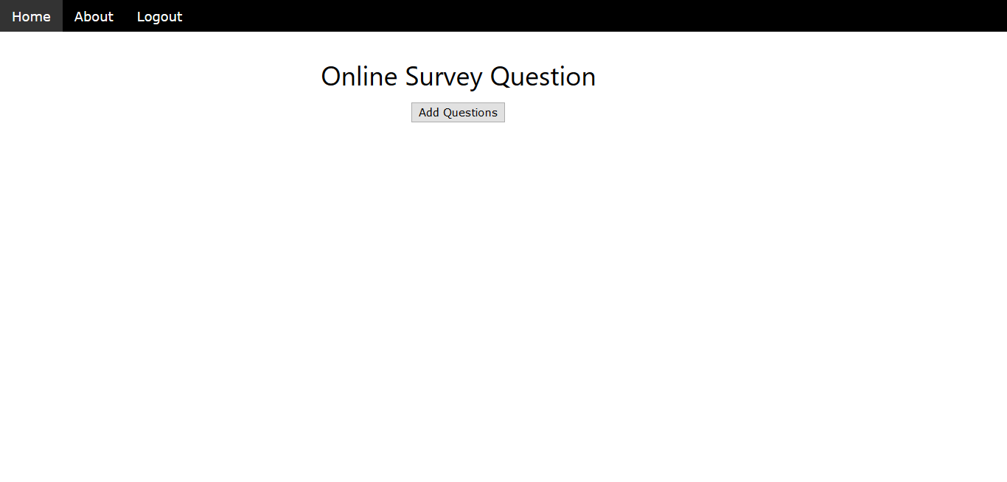

**(9) Add Question**

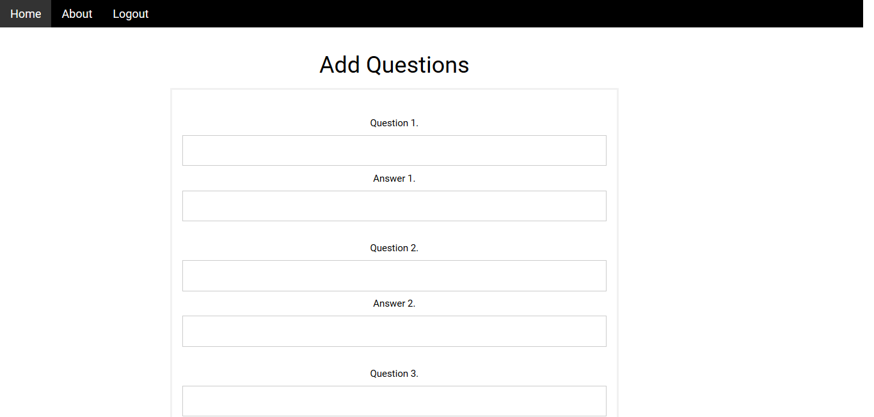

**(10 ) User**

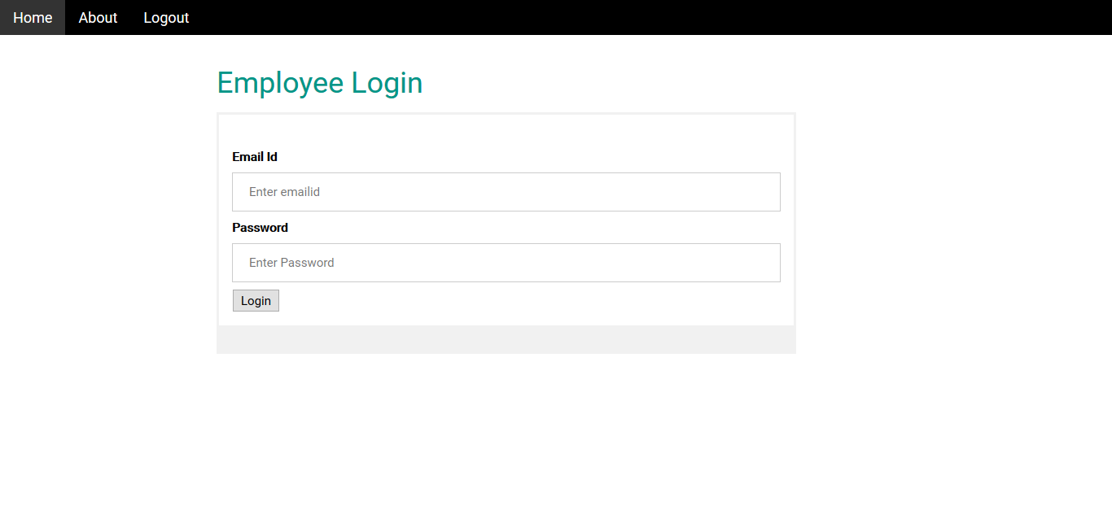

**(11) Attend Quiz**

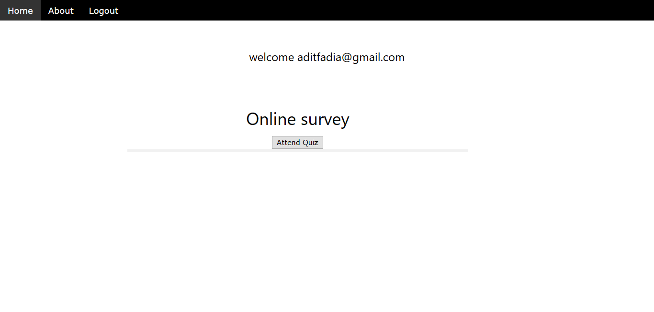

**(12) Answer**

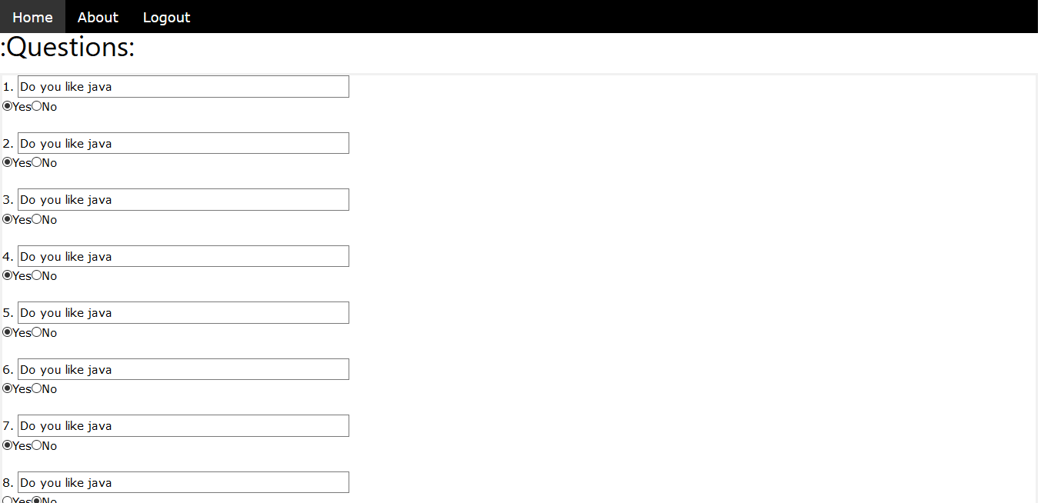

**(13) Result**

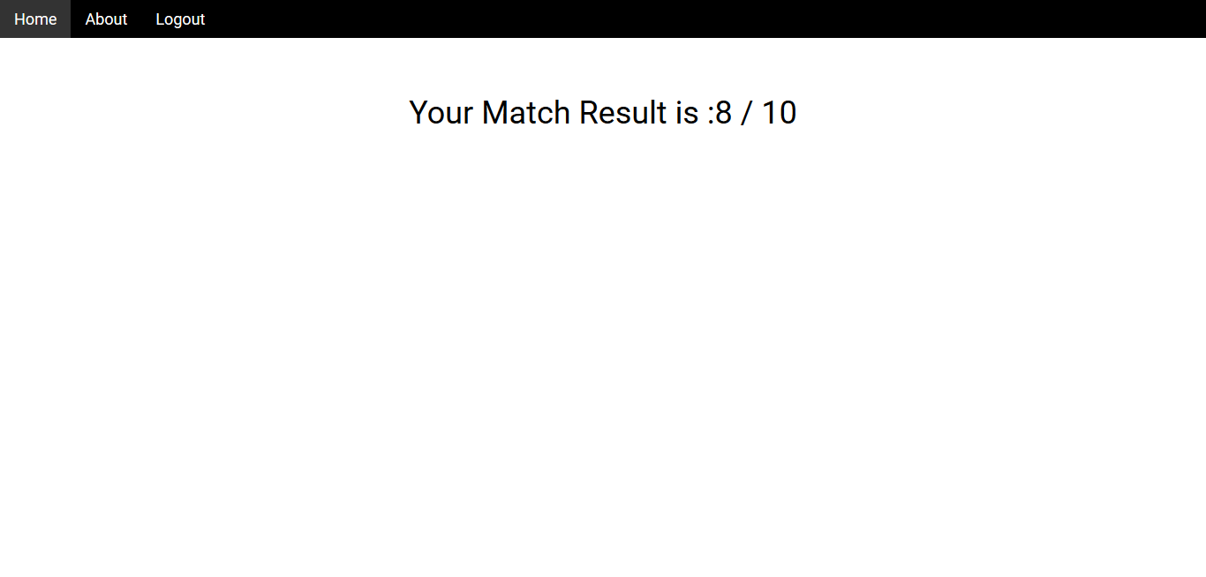

**(d) Team Member Work**

**4) System Implementaton and Outstanding Goal**

To Run this project you have eclipse ide and WebLogic server require and for database connectivity we use Oracle Sql Developer Tool. The goal of make the portal is online human resource management system for medium as well as large enterprise using oracle cloud computing.

5) **What We Learn**

By working on this project we learn how to develop project in servlet and it’s connectivity with oracle database. We also learn Crud Operation and Mail configuration in it.